**Previous Question Solve**

**2020-21**

**Q1. Define opcode. Describe the fetch-execute cycle of a microprocessor with an example. (3 Marks)**

👉 **Answer:**

* **Opcode** = “Operation Code” → Microprocessor কে বলে কোন কাজ করতে হবে (যেমন ADD, MOV, SUB)।
* **Fetch-Execute Cycle** = Microprocessor কাজ করার main cycle:
  1. **Fetch**: Instruction memory থেকে আনা হয় (PC → MAR → MDR → IR)।
  2. **Decode**: Control unit opcode decode করে।
  3. **Execute**: Instruction execute হয় (ALU operation / data transfer)।

**Example**:

MOV AX, 1234h

* Fetch: MOV opcode এবং 1234h data আনা হলো।
* Decode: Control unit বোঝে → AX এ data রাখতে হবে।
* Execute: AX = 1234h.

**Q2. Suppose, AX contains 5ABCh and BX contains 21FCh. Find the difference of AX and BX by using complementation and addition operation. (3 Marks)**

👉 **Answer:**  
AX = 5ABCh  
BX = 21FCh

আমরা চাই: **AX – BX = AX + (2’s complement of BX)**

1. BX = 21FCh
2. 1’s complement = DE03h
3. 2’s complement = DE04h
4. AX + (–BX) = 5ABCh + DE04h = 38C0h

✅ Difference = 38C0h

**Q3. What are data registers? Write down the special features of 80286 μP over 8086 μP. (3 Marks)**

👉 **Answer:**

* **Data Registers:** AX, BX, CX, DX → এগুলোতে arithmetic, logic, I/O data রাখা হয়।
  + AX = Accumulator
  + BX = Base
  + CX = Counter
  + DX = Data
* **Special Features of 80286 over 8086:**
  + 16 MB পর্যন্ত memory address করতে পারে (8086 = 1 MB)।
  + Protected mode introduce করে।
  + Better performance (higher clock speed)।
  + Memory protection, multitasking possible।

**Q4. What is memory segment? Translate the following high level code into equivalent assembly code. (3 Marks)**

High level: A = B – 2 × A

👉 **Answer:**

* **Memory Segment** = Physical memory কে logical block আকারে ভাগ করা হয় (Code, Data, Stack, Extra segment)। প্রতিটা segment register (CS, DS, SS, ES) দিয়ে handle করা হয়।

**Equivalent Assembly:**

; Assume A and B are variables in memory

MOV AX, [B] ; AX = B

MOV BX, [A] ; BX = A

ADD BX, BX ; BX = 2 × A

SUB AX, BX ; AX = B – 2 × A

MOV [A], AX ; Store result back in A

**Q5. What is flag register? How does flag affect on MOV operation? Show, how the instruction ADD AL, BL affect on flags? (3 Marks)**

👉 **Answer:**

* **Flag Register** = Special register that stores status bits after ALU operation.  
  Example flags: Zero (Z), Carry ©, Sign (S), Overflow (O), Parity (P).
* **MOV operation**: শুধু data transfer করে, **flags change করে না**।
* **Example:**

MOV AL, 80h

MOV BL, 80h

ADD AL, BL ; AL = 80h + 80h = 100h (but 8-bit → 00h)

**Effects on Flags:**

* Zero Flag (Z) = 1 (কারণ result = 00h)
* Carry Flag © = 1 (কারণ overflow হয়েছে 8-bit এর বাইরে)
* Sign Flag (S) = 0 (কারণ result positive = 00h)
* Overflow Flag (O) = 1 (কারণ signed overflow ঘটেছে)।

**2019-20**

**Q1. Write down the steps to execute a machine instruction. Illustrate the Intel 8086 Microprocessor organization. (5 Marks)**

👉 **Answer:**  
**Steps of executing machine instruction (Fetch–Decode–Execute cycle):**

1. **Fetch:** Instruction Pointer (IP) → instruction address নেবে, তারপর memory থেকে instruction fetch হবে।
2. **Decode:** Control unit opcode decode করবে।
3. **Execute:** ALU বা data path instruction execute করবে।
4. **Store:** Result register/memory তে যাবে।
5. **Update:** IP পরের instruction এর address সেট করবে।

**8086 Microprocessor Organization:**

* **Bus Interface Unit (BIU):** Instruction fetch, memory addressing করে।
* **Execution Unit (EU):** Instructions decode ও execute করে।
* **Registers:** AX, BX, CX, DX, SP, BP, SI, DI, Segment registers।
* **Control Unit & ALU:** Data processing এবং control signal generate করে।
* 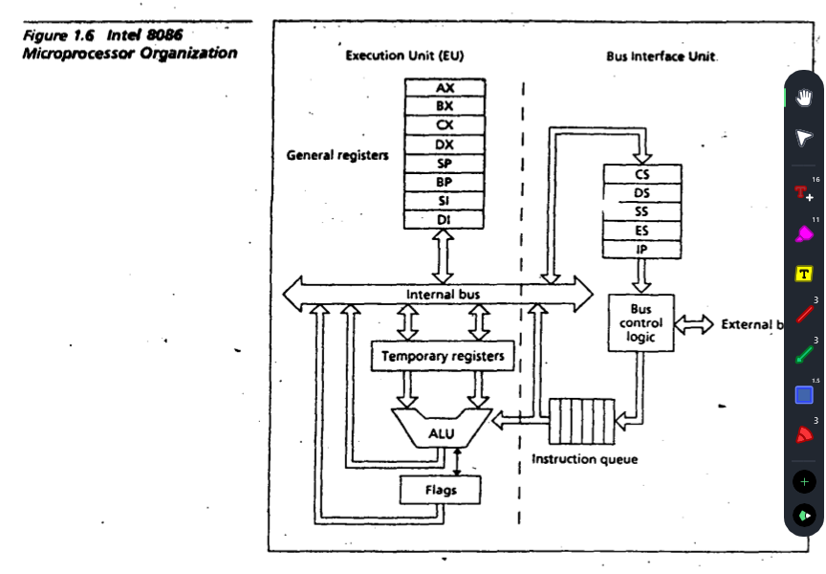

**Q2. Define memory segment. Write down the features of 80286 microprocessor. (2 Marks)**

👉 **Answer:**

* **Memory Segment:** Real mode-এ 1 MB memory কে 64 KB segment এ ভাগ করা হয়। Segment registers: CS, DS, SS, ES।
* **Features of 80286:**
  1. 16 MB পর্যন্ত memory address করতে পারে।
  2. Protected mode introduce করে।
  3. 24-bit address bus, 16-bit data bus।
  4. Multitasking এবং memory protection support করে।

**Q3. Write down the difference between physical and logical memory. A memory location has physical address 80FD2h. In what segment does it have offset B1FD2h? (3 Marks)**

👉 **Answer:**

* **Logical Memory:** Segment:Offset আকারে define হয়।
* **Physical Memory:** Actual memory address (Segment × 10h + Offset)।

Now,

Physical address = (Segment × 10h) + Offset

Given Physical = 80FD2h

Offset = B1FD2h

Solve for Segment:

Segment = (Physical – Offset) / 10h

= (80FD2h – B1FD2h) / 10h

= (–31000h) / 10h

= –3100h (not possible, invalid offset combination)

👉 So, normally given offset doesn’t match physical address → That means this combination is invalid. (Exam এ লিখতে হবে: offset > physical address → invalid segmentation)।

**Q4. Which Intel microprocessor addresses 1T of memory? What is the purpose of the microprocessor in a microprocessor-based computer? (2 Marks)**

👉 **Answer:**

* **Intel 80386** → 32-bit processor, 1 TB memory address করতে পারে।
* **Purpose of Microprocessor:**
  1. Data process করা।
  2. Arithmetic & logic operation করা।
  3. Memory control করা।
  4. Input/Output manage করা।
  5. পুরো computer এর brain হিসেবে কাজ করা।

**Q5. Determine the memory location addressed by the following real mode 80286 register combinations: DS = 1000H and DI = 2000H. Also draw the diagram of memory access. (3 Marks)**

👉 **Answer:**

In the 80286 real mode, the physical memory address is calculated by combining the contents of a segment register (in this case, the Data Segment or DS) and an offset value (from the Destination Index or DI register).

Formula:

Physical Address = (Segment × 10h) + Offset

Here:

DS = 1000h → Base = 1000h × 10h = 10000h

Offset (DI) = 2000h

Physical Address = 10000h + 2000h = 12000h

**Diagram:**

DS (1000h) ---> [Shift Left 4 bits] ---> 10000h

+ 2000h (DI)

-------------

= 12000h (Physical Address)

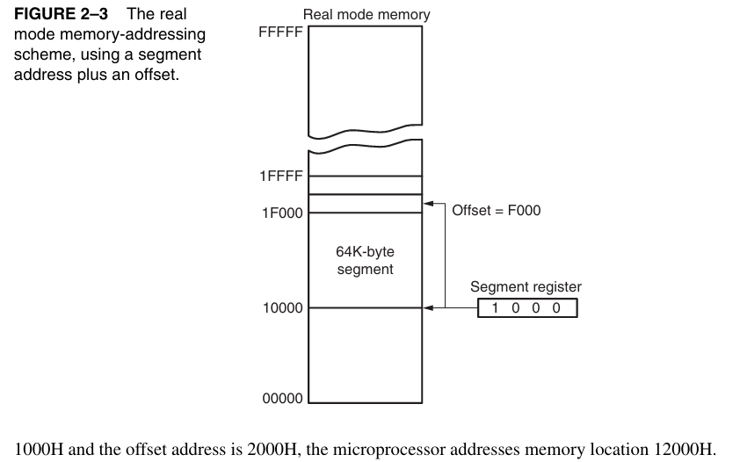

**Question (a)**

**How large is the Windows application programming area? Distinguish between microcontroller and microprocessor. Give the features of 8051.**

**Answer:**  
**Windows application programming area:**

* 32-bit Windows-এ একটি process সাধারণত **2 GB user space** access করতে পারে।
* Special settings দিলে **3 GB পর্যন্ত** access possible।

**Difference between Microcontroller & Microprocessor:**

| **Feature** | **Microcontroller** | **Microprocessor** |
| --- | --- | --- |
| CPU + Memory + I/O | All integrated in one chip | CPU only, needs external memory & I/O |
| Application | Embedded systems (যেমন: home appliances, robotics) | General-purpose computing (PC, Laptop) |
| Cost | Low | Higher |
| Speed | Slower | Faster |

**Features of 8051 Microcontroller:**

* 8-bit CPU
* 128 bytes RAM, 4 KB ROM
* 4 parallel I/O ports
* 2 × 16-bit timers
* Serial communication support (UART)
* On-chip oscillator & clock

**Question (b)**

**What are program-visible registers? What is the purpose of the IP/PC register? Determine the memory location addressed by the following real mode 80286/Core2 register combinations:**

i. DS = 1000H and DI = 2000H  
ii. DS = 2000H and EAX = 00003000H  
iii. SS = 8000H and ESP = 00009000H

**Answer:**  
**Program-visible registers:**

* এগুলো programmer সরাসরি use করতে পারে।
* যেমন: AX, BX, CX, DX, SI, DI, SP, BP, IP, CS, DS, SS, ES

**Purpose of IP/PC register:**

* Instruction Pointer (IP/PC) দেখায় **next instruction কোথায় execute হবে।**

**Memory address calculation (Real mode):**

* Formula: **Physical Address = Segment × 16 + Offset**

i. **DS = 1000H, DI = 2000H**

Physical Address = 1000H * 16 + 2000H

= 10000H + 2000H

= 12000H

ii. **DS = 2000H, EAX = 00003000H**

Physical Address = 2000H * 16 + 3000H

= 20000H + 3000H

= 23000H

iii. **SS = 8000H, ESP = 00009000H**

Physical Address = 8000H * 16 + 9000H

= 80000H + 9000H

= 89000H

**Question (c)**

**What is the flat mode memory system? Protected mode memory addressing allows access to which area of the memory in the 80286 microprocessors?**

**Answer:**  
**Flat mode memory system:**

* Memory এক continuous block হিসেবে দেখা যায়।
* কোন segmentation নেই, programming সহজ।

**Protected mode memory in 80286:**

* CPU **16 MB পর্যন্ত memory access করতে পারে।**
* Segmentation + protection mechanisms দ্বারা memory areas access possible with privileges।

**Question (d)**

**What are the differences between a register and a memory location? List one special function for each of the data registers AX, BX, CX, and DX.**

**Answer:**

| **Feature** | **Register** | **Memory Location** |
| --- | --- | --- |
| Speed | Very fast (CPU-এর ভিতরে) | Slower (RAM থেকে access) |
| Accessibility | Direct access possible | Address দ্বারা access করতে হয় |
| Size | Limited (16/32-bit) | Large, depends on RAM |
| Function | Temporary storage computation-এর জন্য | Permanent বা temporary storage |

**Special function of data registers:**

* **AX (Accumulator):** Arithmetic operations (ADD, SUB, MUL, DIV)
* **BX (Base register):** Indexed addressing, base pointer in memory
* **CX (Count register):** Loop counter, shift/rotate operations
* **DX (Data register):** I/O operations, multiplication/division

**Q1. What is an n-bit processor?**

**Answer:**

* A processor is called an **n-bit processor** যদি তার **ALU, registers, and data bus** একসাথে n bits data handle করতে পারে।
* Example:
  + **8085 → 8-bit processor** (একসাথে 8 bits handle করে)
  + **8086 → 16-bit processor** (একসাথে 16 bits handle করে)

So, **n-bit = একবারে কত bit data process করতে পারে processor**।

**Q2. Distinguish between 8085 and 8086**

| **Feature** | **8085** | **8086** |
| --- | --- | --- |
| Processor type | 8-bit | 16-bit |
| Data bus width | 8-bit | 16-bit |
| Address bus | 16-bit → 64 KB memory | 20-bit → 1 MB memory |
| Instruction set | Simpler, fewer instructions | Larger, more powerful instructions |
| Multiprocessing | Not supported | Supported (basic level) |
| Year introduced | 1977 | 1978 |

**Q3. “Computer works on 0 and 1” – Explain this statement**

**Answer:**

* Computer internally সবকিছু **binary system (0 and 1)** এ process করে।
* কারণ transistor-এর 2 অবস্থা থাকে:
  + **ON = 1**
  + **OFF = 0**
* যেকোনো data (number, text, image, sound) → শেষে সবকিছু binary code-এ রূপান্তর হয়।
* তাই বলা হয়: **Computer works on 0 and 1.**

**Q4. Describe IN and OUT instruction with respect to 8086**

**Answer:**

1. **IN instruction:**
   * Use → Input device থেকে data পড়তে।
   * Format → IN accumulator, port_address
   * Example:
   * IN AL, 20H ; port 20H থেকে data নেবে AL register-এ
2. **OUT instruction:**
   * Use → Data পাঠাতে (output device-এ)।
   * Format → OUT port_address, accumulator
   * Example:
   * OUT 20H, AL ; AL register-এর data পাঠাবে port 20H-এ

👉 **Note:** IN/OUT instructions সবসময় **Accumulator (AL/AX)** এর সাথে কাজ করে।

**1. Who developed the Analytical Engine?**

* **Analytical Engine** → Developed by **Charles Babbage** in 1837.
* এটাকে বলা হয় **“First design of a general-purpose computer”**।
* Charles Babbage = “Father of Computer”.

**Block diagram of a Microprocessor-based Computer System**

A typical microprocessor-based computer system এ থাকে:

1. **Microprocessor (CPU)**
2. **Memory (RAM, ROM)**
3. **Input Devices (keyboard, mouse, etc.)**
4. **Output Devices (monitor, printer, etc.)**
5. **System Bus (Data bus, Address bus, Control bus)**

**Diagram structure:**

+-------------------+

Input -----> | |

| Microprocessor | <------> Memory (RAM/ROM)

Output <----- | |

+-------------------+

|

System Bus

(Data bus, Address bus, Control bus)

**8086 Architecture (Block Diagram Overview)**

8086 divided into **two units**:

1. **Bus Interface Unit (BIU)**
   * Instruction Queue (6-byte)
   * Segment Registers (CS, DS, SS, ES)
   * Instruction Pointer (IP)
   * Address Generation
2. **Execution Unit (EU)**
   * ALU
   * General Purpose Registers (AX, BX, CX, DX)
   * Pointer & Index Registers (BP, SP, SI, DI)
   * Flag Register
   * Control Circuit

👉 BIU = Fetch instruction from memory  
👉 EU = Execute instruction

**2. Program-visible registers in 8086**

8086 এ যেসব register directly programmer দেখতে/ব্যবহার করতে পারে:

**🔹 General Purpose Registers**

* **AX (Accumulator)** → Arithmetic, logic, I/O operations
* **BX (Base)** → Memory addressing (base register)
* **CX (Count)** → Loop counter, shift/rotate counter
* **DX (Data)** → I/O operations, multiply/divide

Each = 16-bit, divided into high/low (AH, AL, BH, BL …)

**🔹 Segment Registers**

* **CS (Code Segment)** → Program instructions store
* **DS (Data Segment)** → Data store
* **SS (Stack Segment)** → Stack operations
* **ES (Extra Segment)** → String operations

**🔹 Pointer and Index Registers**

* **IP (Instruction Pointer)** → Next instruction address
* **SP (Stack Pointer)** → Top of stack address
* **BP (Base Pointer)** → Stack data access
* **SI (Source Index)** → Source string address
* **DI (Destination Index)** → Destination string address

**🔹 Flag Register**

(Next question e detail বলছি)

**3. Flag Register of 8086**

Flag Register = 16-bit, কিন্তু সবগুলো bit ব্যবহার হয় না।

**🔹 Main Flags:**

1. **CF (Carry Flag)** → Carry/borrow out of MSB
2. **PF (Parity Flag)** → 1 if result has even number of 1s
3. **AF (Auxiliary Carry Flag)** → For BCD operations
4. **ZF (Zero Flag)** → 1 if result = 0
5. **SF (Sign Flag)** → 1 if result negative
6. **OF (Overflow Flag)** → Signed overflow

**🔹 Control Flags:**

1. **IF (Interrupt Flag)** → Interrupt enable/disable
2. **DF (Direction Flag)** → String direction (increment/decrement)
3. **TF (Trap Flag)** → Single-step execution (debugging)

**4. Memory Access in Real Mode**

* **Real Mode** = 8086 default mode (20-bit address bus)
* Memory size = **1 MB (2^20 = 1,048,576 bytes)**
* Address formed using:
* Physical Address = Segment × 10H + Offset
* Example:
* DS = 2000H, Offset = 1234H
* Physical Address = 2000H × 10H + 1234H
* = 20000H + 1234H
* = 21234H

**5. Flat Mode Memory System**

* **Flat memory model** = সব memory একটি continuous block হিসেবে দেখা হয় (no segmentation)।
* Modern 32-bit/64-bit processors এই mode ব্যবহার করে।
* Programmer কে segment calculation করতে হয় না।

👉 Example: In protected mode (32-bit), physical & linear addresses treated as one big space.

**6. Memory Paging Mechanism**

* Paging = Memory management technique in protected mode.
* Physical memory কে ছোট ছোট **fixed-size blocks (pages)** এ ভাগ করা হয়, usually 4 KB each.
* CPU generates a **logical address → translated to physical address** using page tables.
* Benefit:
  + Efficient use of memory
  + Supports virtual memory
  + Protects processes from each other